GRADE QUALITY OF CONSTRUCTION

Selection of the appropriate quality grade is a means of adjusting the base value schedule upward or
downward by percentages. An average or base C grade is a factor of 1.00. Grading is the system whereby dwellings are compared to a standard and placed in an appropriate category taking into consideration many factors such as:
- Quality of construction, materials, and workmanship
- Architectural design
- Interior and exterior ornamentation
- Cost of construction
- Construction detail
- Quality, number, and fenestration of windows
- Quality of interior trim
- Number and type of extra features
- Number of built-in appliances and features

Since the quality of materials and workmanship normally do not change as a structure ages, a
building will typically keep its original grade of construction unless it undergoes significant remodeling. Therefore, the reviewer must be very careful in distinguishing physical condition from quality of construction.

The grade is normally assigned to the main portion of a building. The grade finally selected should represent a composite judgment of the overall quality grade for the quality of materials and workmanship consistent throughout the construction of a specific building.

When this is not the case, it is necessary to weight the quality of each major component to arrive at the appropriate overall quality grade. Also, equal consideration must be given to any additions whose materials and workmanship are inconsistent with the quality of the main portion of the building.

It is extremely important that all appraisers grade in a similar manner and consider the same basic features when grading to promote accuracy and consistency within the county. If dwellings are not properly graded, the schedule developed will not work in applying market values. The Team Lead for Appraisal should periodically check appraiser’s grade assignments to assure consistency.
2024 Grade Conversion:

We are converting our grade system from numbers to letters that largely mirrors the UAD (Uniform Appraisal Dataset) and Core Logic Marhsall & Swift Cost Service ratings. There will be 6 main letters (X through E with C being average quality). We will have +/- for X, A, B, and C.

The following table shows the new construction quality ratings with the associated grade factor that adjusts the base cost in the 2024 cost new model.

Grade | Description | Factor
X+ | EXCELLENT + | 2.84
X | EXCELLENT | 2.37
X- | EXCELLENT - | 2.18
A+ | VERY GOOD + | 1.87
A | VERY GOOD | 1.59
A- | VERY GOOD - | 1.49
B+ | GOOD + | 1.38
B | GOOD | 1.27
B- | GOOD - | 1.12
C + | AVERAGE + | 1.05
C | AVERAGE | 1.00
C - | AVERAGE - | 0.95
D | FAIR | 0.85
E | LOW | 0.74

The table below shows the conversion from the numberical ratings in 2023 to the new letter grades in 2024:

Grade Number Ranges 2023 and older | New Grade 2024
80 or less | E
85-90 | D
95 | C-
100 | C
105 | C+
110-115 | B-
120-135 | B
140-145 | B+
150-160 | A-
165-180 | A
185-195 | A+
200-225 | X-
230-290 | X
295 or higher | X+

Marshall & Swift - RCH

The Core Logic/Marshall and Swift building cost manual is a comprehensive reference guide used in the construction industry to estimate the costs associated with various building projects. It includes detailed information on material costs, labor costs, equipment costs, and other expenses related to construction. The manual provides cost breakdowns for different types of construction projects, such as residential, commercial, or industrial buildings, as well as different regions or markets. Additionally, it includes factors such as inflation rates, market trends, and regulatory requirements that can impact construction costs. Cost manuals are essential tools for contractors, architects, engineers, and other professionals involved in the planning and budgeting of construction projects. It is specifically helpful to professional appraisers when estimating the replacement cost new of improvements to the property.

QUALITY OF CONSTRUCTION

Examination of both materials and workmanship is fundamental when determining the overall quality of construction. While the quality of materials and workmanship of individual building components may vary, the overall quality will tend to be consistent for the entire residence. Furthermore, the quality of materials and workmanship will tend to influence each other.

Workmanship is often superficial, and its quality can be easily observed. Solid and level floor structures, plumb walls, smooth finish on concrete and plastered surfaces, mitered joints in both exterior and interior woodwork, and proper fitting of doors and windows are all indications of better-quality workmanship.

As with workmanship, the quality of materials is usually apparent during inspection of the residence. The grade of wood, floor cover or fixtures, whether standard or custom, is the primary indication of the quality of materials.

Design can be another indication of quality. Residences of lower quality utilize stock plans and usually have a simple floor plan. Higher-quality residences are often individually designed with considerable attention given to detail.

To further assist the appraiser in determining quality, basic descriptions are provided for each different type of residence at each quality level. Basic descriptions are not intended to be detailed specifications of a particular residence but are intentionally general to emphasize the most prominent characteristics of all residences within a given type and quality. Photographs which depict both type and quality are shown as well. However, photographs alone cannot be used to determine quality, since the front elevation may not truly represent the overall quality of both the interior and exterior of the residence.

Size and the number of appointments may also influence quality. However, these items do not remain constant over time because consumer needs and housing requirements change. For example, newer homes tend to have more plumbing fixtures and built-in appliances than older homes.

Grade E (Low Quality)

Grade E residences are of low-cost construction and meet minimum building code requirements. Interior and exterior finishes are plain and inexpensive with little, or no attention given to detail. Architectural design is concerned with function, not appearance. Minimum roof pitch, roof overhang and fenestration will be encountered. Straight walls only, without indentations, simple box shape overall.

Dwellings with this quality rating are of basic quality and lower cost; some may not be suitable for year-round occupancy. Such dwellings are often built with simple plans or without plans, often utilizing the lowest quality building materials. Such dwellings are often built or expanded by persons who are professionally unskilled or possess only minimal construction skills. Electrical, plumbing, and other mechanical systems and equipment may be minimal or nonexistent. Older dwellings may feature one or more substandard or nonconforming additions to the original structure.

EXTERIOR WALL
Minimum fenestration with inexpensive sash with little or no trim.
ROOF
Rafters or prefabricated trusses with plywood or other inexpensive sheathing with a lightweight composition shingle or a built-up with gravel roof cover. Roof slope is usually less than 4 in 12 with no eaves.
INTERIOR FINISH
Walls are inexpensive taped drywall with paint or textured finish. Kitchen and baths may have enamel painted ceiling and walls. Cabinets are paint-grade wood or vinyl veneer with low-cost laminated plastic countertops. Doors are hollow core with low-cost hardware. Minimal amount of closet space.
FLOOR COVER
Inexpensive carpet and asphalt or vinyl composition tile floor cover is used.

The illustrations on the following pages attempt to show the quality and construction class of the various residences as the appraiser would be able to determine them from an observation of the exterior. The details of workmanship, design and exterior-finish materials often indicate the quality to be found inside. Some items which affect the quality, and which may be observed from the exterior, are roof pitch and type. Costs of shed, gable, and hip roofs generally ascend in that order. Typically, a cut-up roof requires more labor and materials than a simply designed roof.

Eave soffits and gutters, or their absence, and the trim and ornamentation should be observed, as well as the quantity and quality of fenestration. Fenestration, roof pitch, design, materials, and workmanship are the major indicators of quality from an exterior view. In most cases, the interior improvements will be commensurate with the exterior, but even when they are not, the exterior design and finish have a great effect on the determination of quality.

Grade E Illustrations

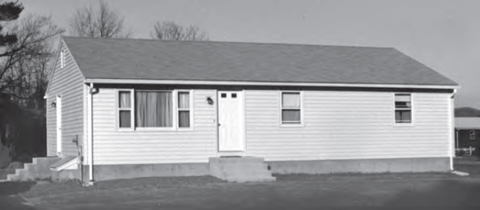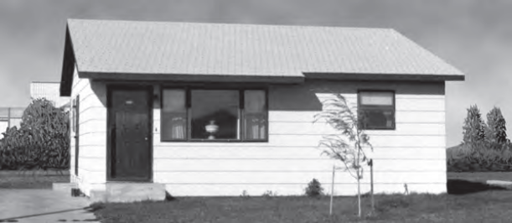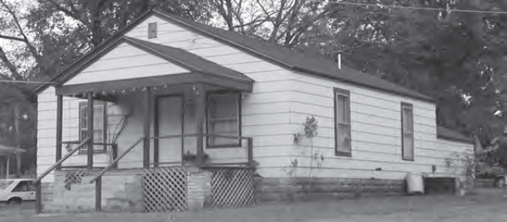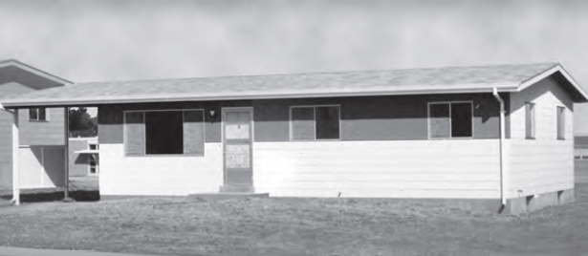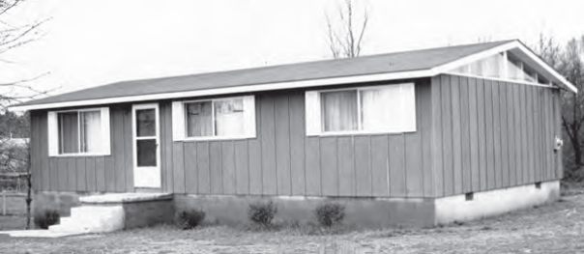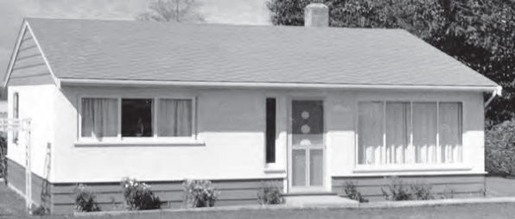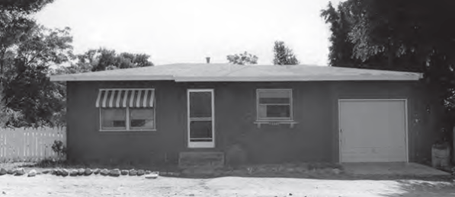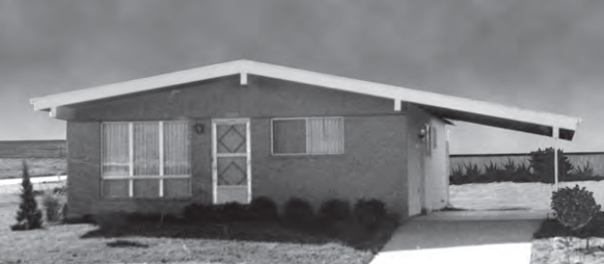

Grade D (Fair Quality)

Grade D residences are frequently mass produced. Low-cost production is a primary consideration. Although overall quality of materials and workmanship is below average, these houses are not substandard and will meet minimum construction requirements of lending institutions, mortgage insuring agencies and building codes. Interior finish is plain with few refinements. Design is from stock plans, and ornamentation is usually limited to the front elevation.

Dwellings with this quality rating feature economy of construction and basic functionality as main
considerations. Such dwellings feature a plain design using readily available or basic floor plans
featuring minimal fenestration and basic finishes with minimal exterior ornamentation and limited
interior detail. These dwellings meet minimum building codes and are constructed with inexpensive,
stock materials with limited refinements and upgrades.

EXTERIOR WALL
Moderate fenestration with inexpensive sash is typical. Front elevation may have inexpensive trim.
ROOF
Rafters or prefabricated trusses with plywood or other inexpensive sheathing with a lightweight composition shingle or a built-up with small rock roof cover. Roof slope is usually less than 4 in 12 with a minimal eave.
INTERIOR FINISH
Interior walls are taped and painted drywall with enamel painted walls and ceilings in kitchen and baths. Inexpensive stock cabinets of paint-grade wood or vinyl veneer in kitchen with a small pullman or vanity in bath. Countertops are laminated plastic with a small splash. Stock, hollow-core doors with inexpensive hardware. Minimal amount of closet space.
FLOOR COVER
Carpet, asphalt or vinyl composition tile floor cover is used.

The Grade D residence is typical of the mass-produced house built to minimum FHA and VA standards. Designs are simple rectangular shapes, sash and doors are few and low cost, roof lines are plain and typically gable. Some will have minimum ornamentation such as shutters, brick skirts or window boxes. Grade D residences could easily be the “Average” standard quality for certain areas.

Grade D Illustrations
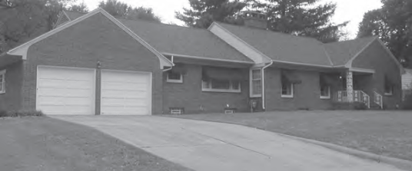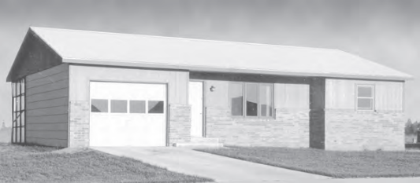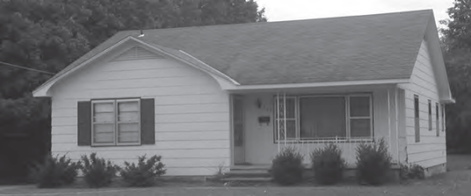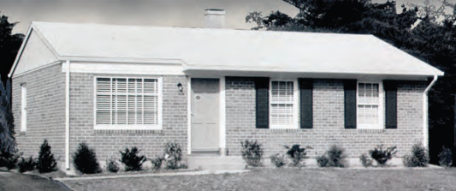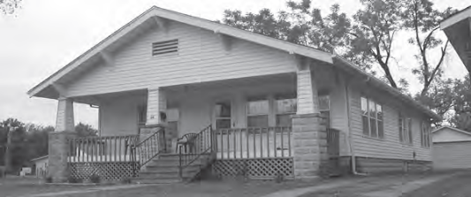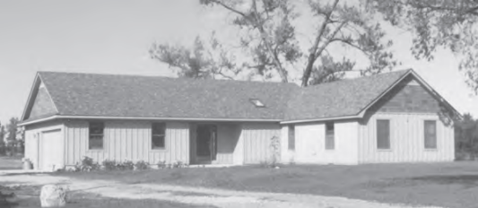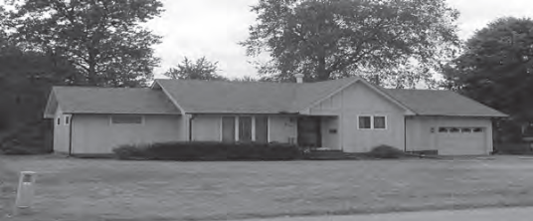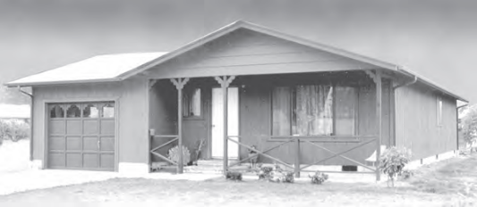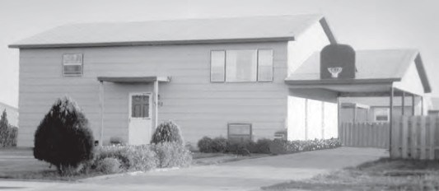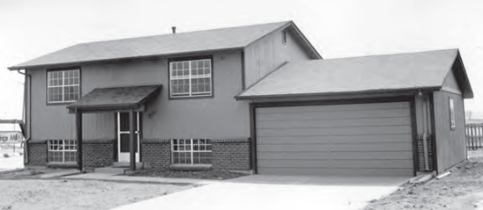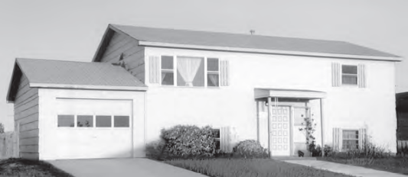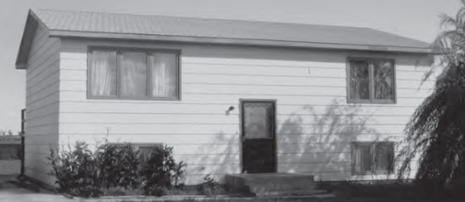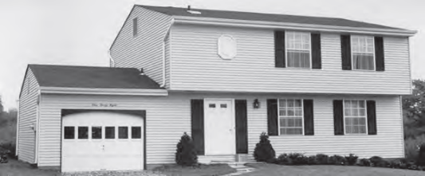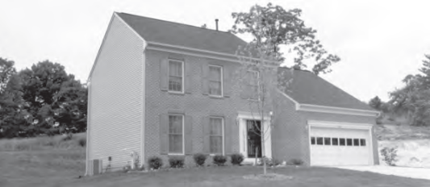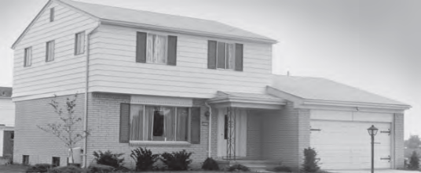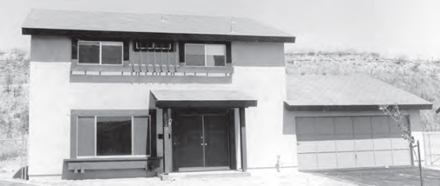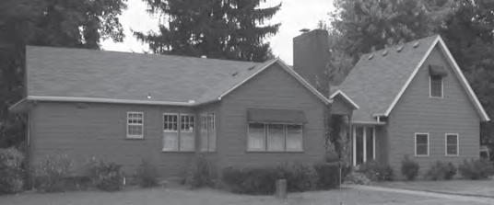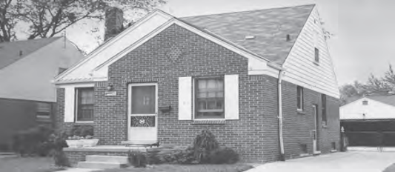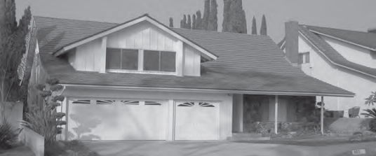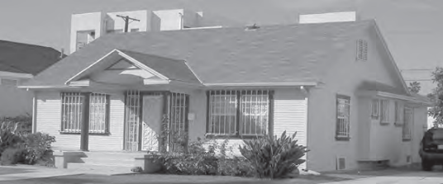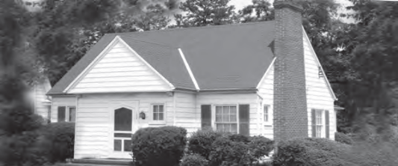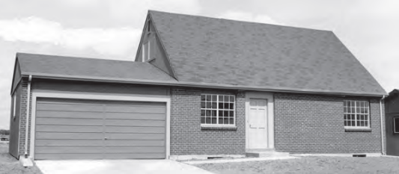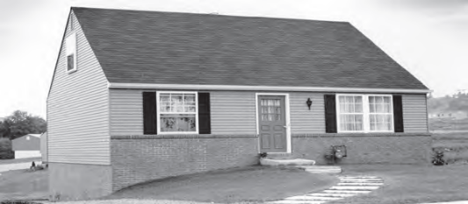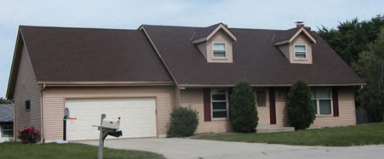

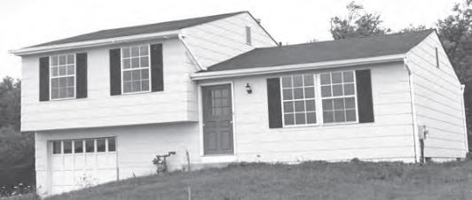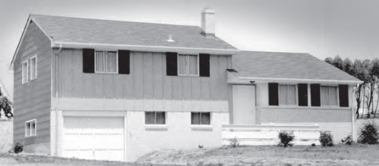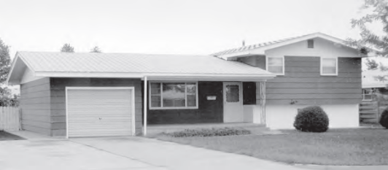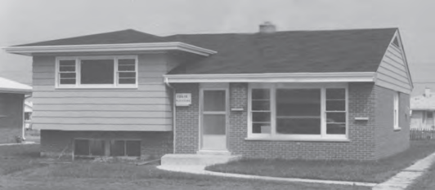

Grade C (Average Quality)

Grade C residences are usually mass produced and will meet or exceed the minimum construction requirements of lending institutions and building codes. By most standards, the quality of materials and workmanship is acceptable, but does not reflect custom craftsmanship. Cabinets, doors, hardware, and plumbing are usually stock items. Architectural design will include ample fenestration and some ornamentation on the front elevation.

Dwellings with this quality rating meet or exceed the requirements of applicable building codes.
Standard or modified standard building plans are utilized and the design includes adequate fenestration and some exterior ornamentation and interior refinements. Materials, workmanship, finish, and equipment are of stock or builder grade and may feature some upgrades.

EXTERIOR WALL
Standard aluminum sash or wood sash is typical of the fenestration.
ROOF
Rafters or prefabricated trusses with exterior-grade plywood or wood sheathing with a medium-weight composition shingle or a built-up with small rock roof cover. Roof slope is usually 5 in 12 or less.
INTERIOR FINISH
Interior walls are taped and painted drywall with an allowance for some inexpensive wallpaper or paneling. Kitchen and baths have enamel painted walls and ceilings. Prefinished plywood cabinets in the kitchen with a small Pullman or vanity in bath areas. Countertops are laminated plastic or ceramic tile. Doors are medium grade, hollow core with standard-grade hardware. Baseboard and casings are stock. An adequate amount of closet space. Workmanship throughout is of average quality.
FLOOR COVER
Carpet, asphalt or vinyl composition tile floor cover is used.

The Grade C residence will generally exceed FHA design and specifications. Roof slopes will increase, as well as the overhangs and complexity of the roof style. Better fenestration and ornamental trims are found on the street exposures. House shapes will be rectangular to “L” shaped with some corners or indentations that add to the cost.

Grade C Illustrations
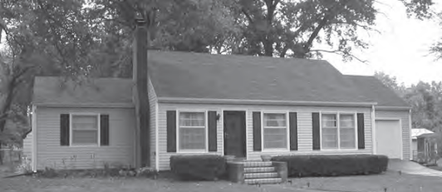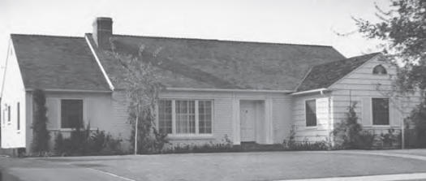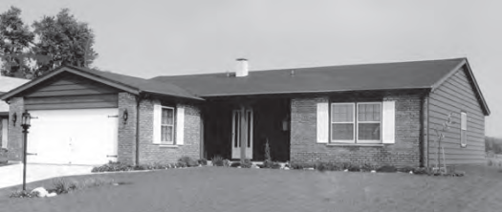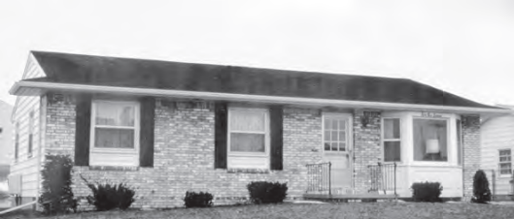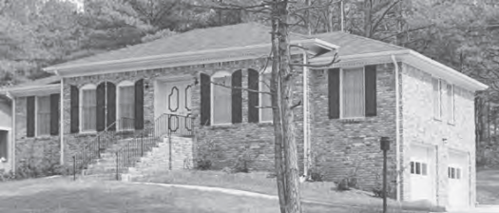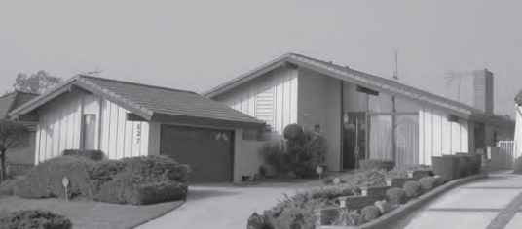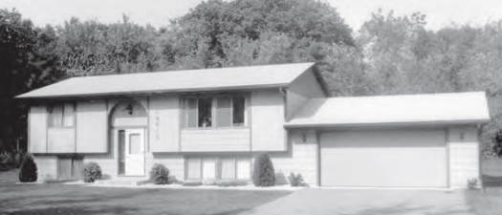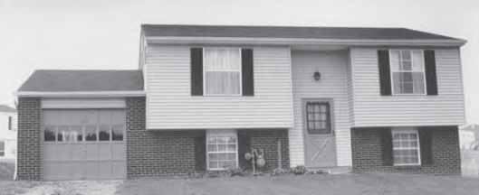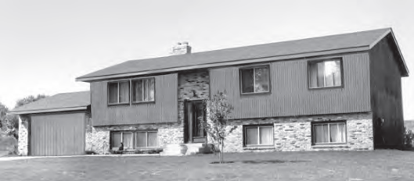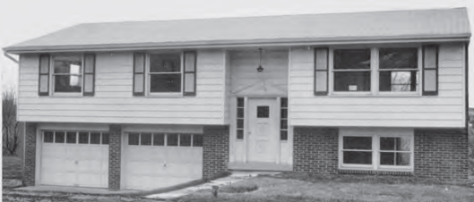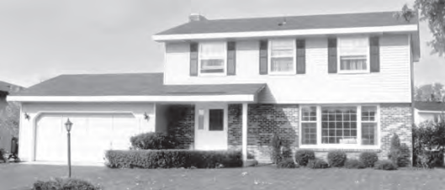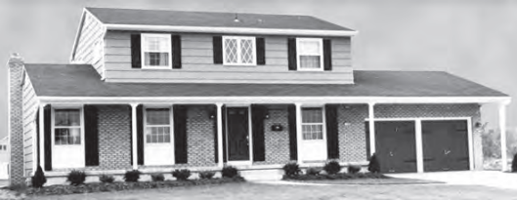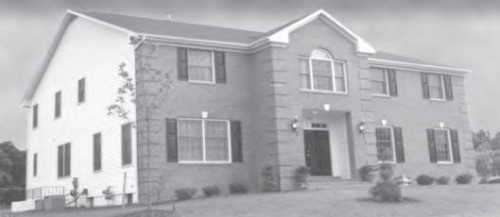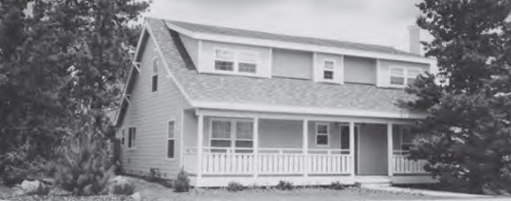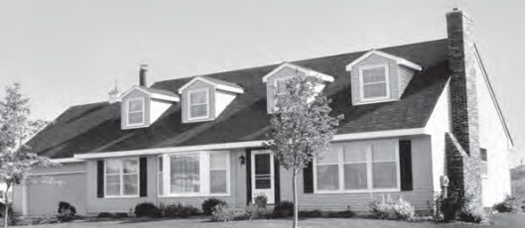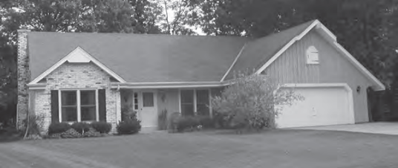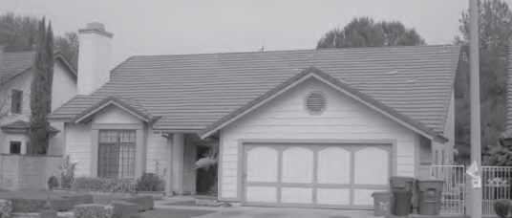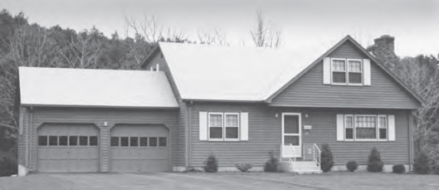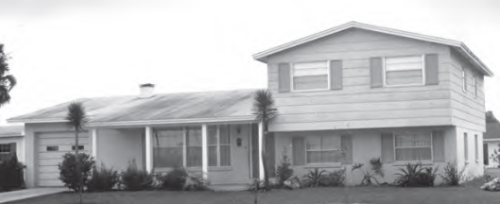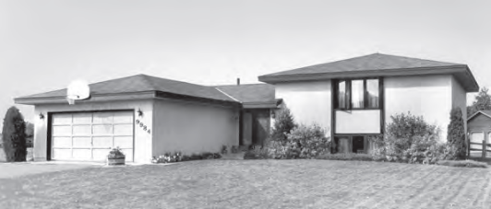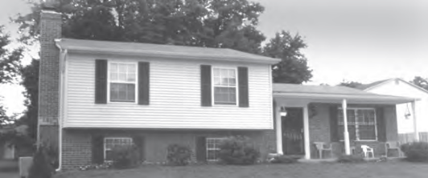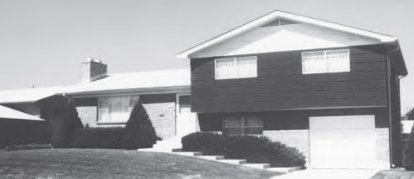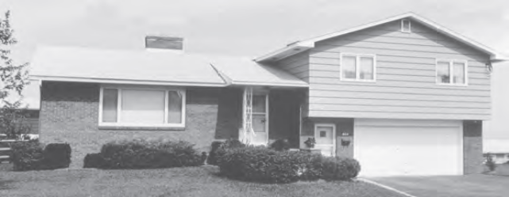

Grade B (Good Quality)

Grade B residences may be mass produced in above-average residential developments or built for an individual owner. Good-quality standard materials are used throughout. These houses generally exceed the minimum construction requirements of lending institutions and building codes. Some attention is given to architectural design in both refinements and detail. Interiors are well finished, usually having some good-quality wallpaper or wood paneling. Exteriors have good fenestration with ornamental materials or other refinements.

Dwellings with this quality rating are residences of higher quality built from individual or readily available designer plans in above-standard residential tract developments or on an individual property owner's site. The design includes significant exterior ornamentation and interiors that are well finished. The workmanship exceeds acceptable standards and many materials and finishes throughout the dwelling have been upgraded from "stock" standards.

EXTERIOR WALL
Good fenestration using good-quality sash. Some ornamental trim.
ROOF
Wood rafters and sheathing with hips and valleys.
INTERIOR FINISH
Interior walls are taped and painted drywall with some good-quality wallpaper or wood paneling. Kitchen and baths have enamel-painted walls and ceilings. An ample amount of cabinetry with natural wood-veneer finish is used in the kitchen, with a large pullman or vanity in the bath areas. Countertops and splash are laminated plastic, ceramic tile or simulated marble. Ceilings are painted drywall. Some small areas, i.e., entries or foyers, may have vaulted or cathedral ceilings. Doors are good quality, hollow core with attractive hardware. Baseboard and casings are hardwood or softwood and have mitered corners. Walk-in closets or large sliding door wardrobes. Ample linen and storage closets. Workmanship throughout is of good quality.
FLOOR COVER
Carpet, asphalt or vinyl composition tile floor cover is used.

Grade B is the next level in cost for residential housing. Good-quality residences are typical of the upper middle class or move-up type development. From the exterior, they frequently resemble the Very Good (A) residence, but usually with less detail and workmanship in the interior. This quality cost level could easily be Average Quality (C) or Very Good Quality (A) in your area.

Grade B Illustrations
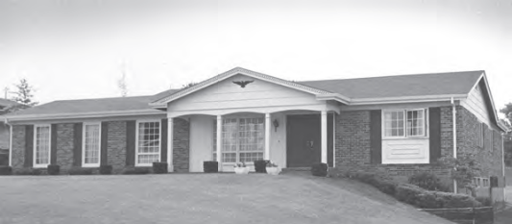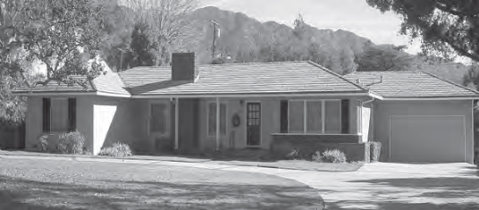
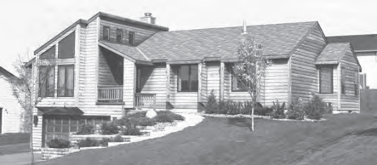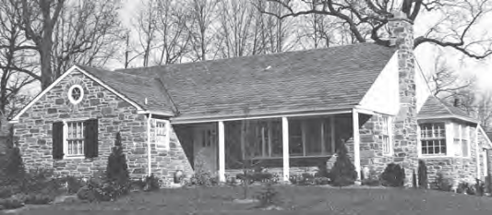
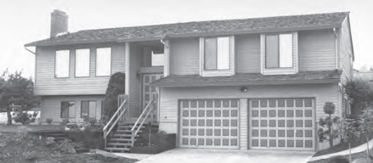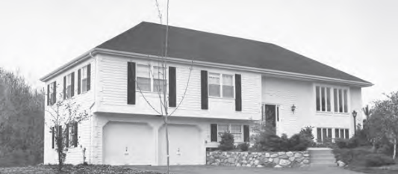
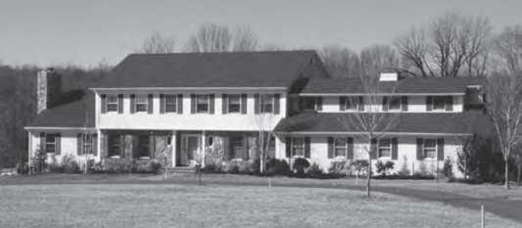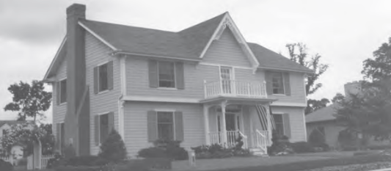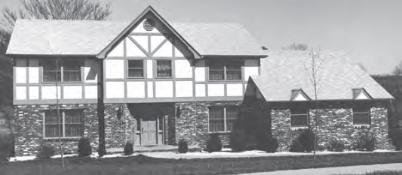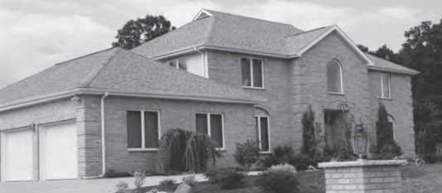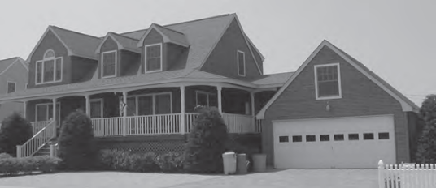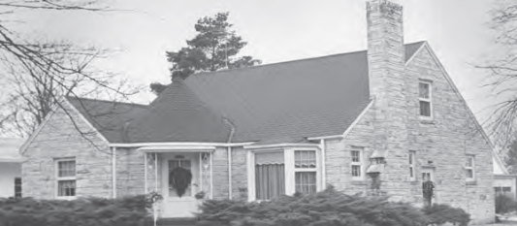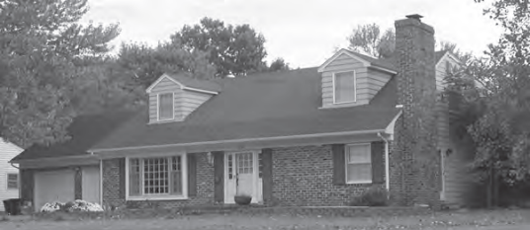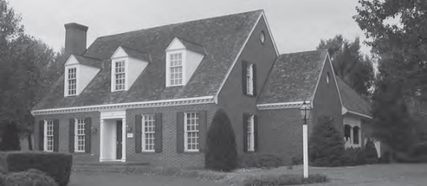
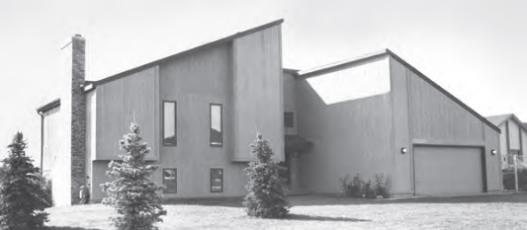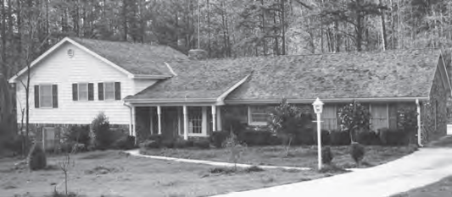

Grade A (Very Good Quality)

Grade A residences are typical of those built-in high-quality tracts or developments and are frequently individually designed. Attention has been given to interior refinements and detail. Exteriors have good fenestration with some custom ornamentation.

Dwellings with this quality rating are often custom designed for construction on an individual
property owner's site. However, dwellings in this quality grade are also found in high-quality tract developments featuring residences constructed from individual plans or from highly modified or
upgraded plans. The design features detailed, high-quality exterior ornamentation, high-quality
interior refinements, and detail. The workmanship, materials, and finishes throughout the dwelling are generally of high or very high quality.

EXTERIOR WALL
Fenestration is well designed with high-quality sash. Custom ornamentation and trim are used.
ROOF
Wood rafters and sheathing with hips and valleys.
INTERIOR FINISH
Interior walls are taped and painted drywall with high-grade paper or vinyl wall covering, hardwood paneling or ceramic tile. Ample amount of cabinetry, which may include such specialty cabinetry items as a cooking island, bar, desk, etc. High-quality pullman or vanity cabinets. Ceramic tile or highest-quality laminated plastic countertops and splash. Ceilings are mostly painted drywall, with some molding and coving details. Vaulted or cathedral ceilings will usually be found in master bedrooms and entries. Raised-panel hardwood veneer or enameled doors with good-quality hardware. Base, casings and moldings have tight mitered corners. Spacious walk-in closets or wardrobes and large linen storage closets.
FLOOR COVER
High-quality carpet, hardwood, sheet vinyl and ceramic tile.

Grade A is typical of high-quality tracts or developments. It is also frequently an individually designed home in the move-up bracket. This quality cost level could easily be Good Quality or Excellent Quality in your area. Special attention is given to exterior as well as interior details. Irregular shapes and angles will be common, as well as large eaves and overhangs.

Grade A Illustrations
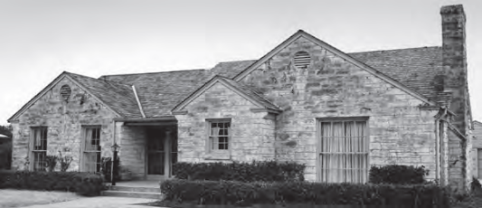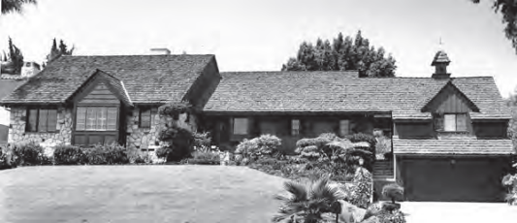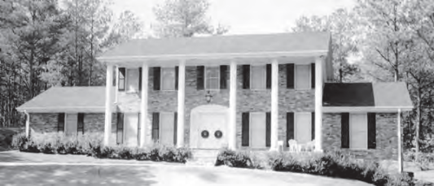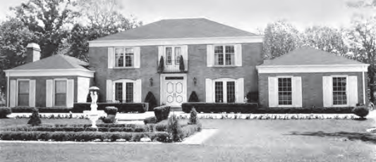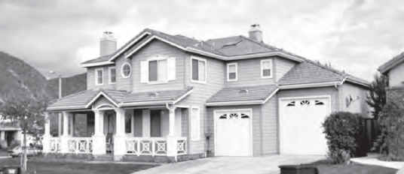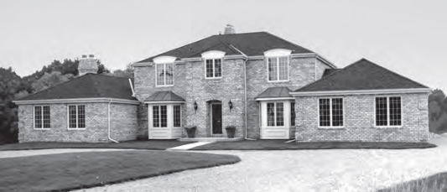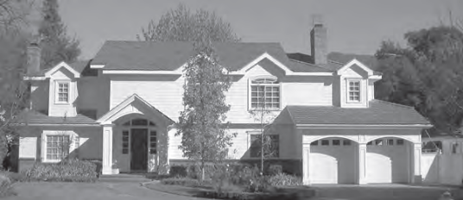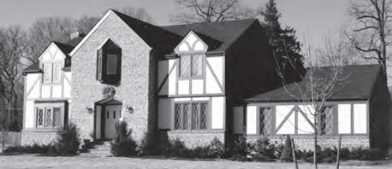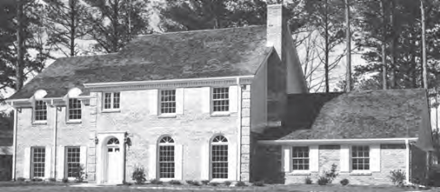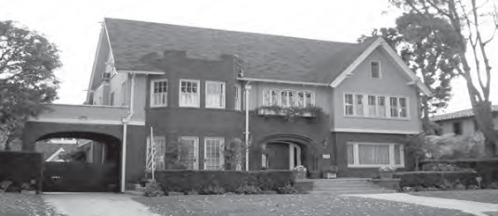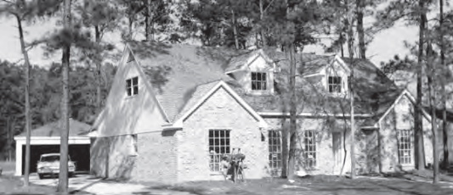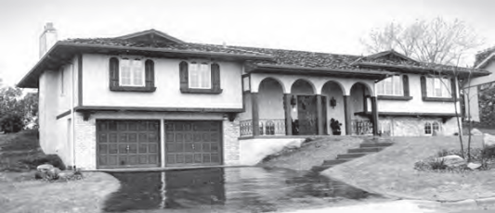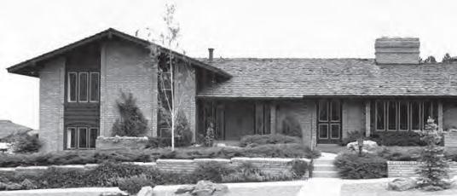

Grade X (Excellent Quality)

Grade X residences are usually individually designed and are characterized by the high quality of workmanship, finishes and appointments and the considerable attention to detail.

Dwellings with this quality rating are usually unique structures that are individually designed by an
architect for a specified user. Such residences typically are constructed from detailed architectural plans and specifications and feature an exceptionally high level of workmanship and exceptionally high-grade materials throughout the interior and exterior of the structure. The design features exceptionally high-quality exterior refinements and ornamentation, and exceptionally high-quality interior refinements. The workmanship, materials, and finishes throughout the dwelling are of exceptionally high quality.

EXTERIOR WALL
Fenestration is well designed with high-quality sash. Custom ornamentation and trim, select brick, cut stone, high-quality siding, etc. are used.
ROOF
Heavy wood rafters and sheathing with hips and valleys.
INTERIOR FINISH
Interior walls are taped and painted drywall with high-grade paper or vinyl wall covering, hardwood paneling or ceramic tile. Built-in book shelving and ample cabinets, which may include such specialty cabinetry items as a cooking island, bar, desk, etc. High quality pullman or vanity cabinets in bathrooms and dressing areas. Ceramic tile, marble or highest-quality laminated plastic countertops and splash. Ceilings are mostly painted drywall with molding and coving details and other ornamentation with some degree of intricacy in their design and/or finish. Vaulted or cathedral ceilings will usually be found in master bedrooms, dining, great or family rooms, as well as entries. Raised panel hardwood veneer or enameled doors with good-quality hardware. Base, casings and moldings have tight mitered corners. Spacious walk-in closets or wardrobes with many built-in features. Large linen storage closets and pantry are fully shelved.
FLOOR COVER
High-quality carpet or hardwood (parquet or plank), terrazzo, and vinyl, ceramic or
quarry tile.

Grade X is a very gracious residence, usually designed individually, with good detail and workmanship. Special attention is given to both the quality and the quantity of exterior and interior ornamentation. Very high-quality floor and wall coverings may be found. This quality cost level could also be Very Good (A) Quality in your area.
Grade X Illustrations
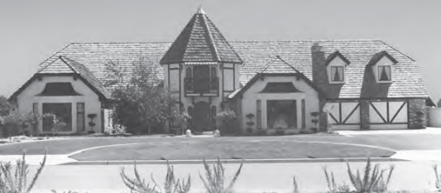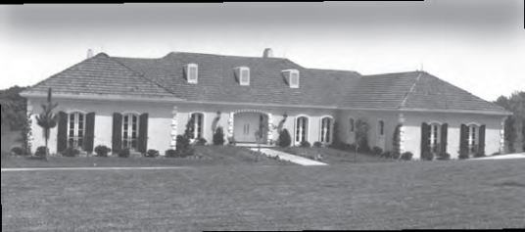
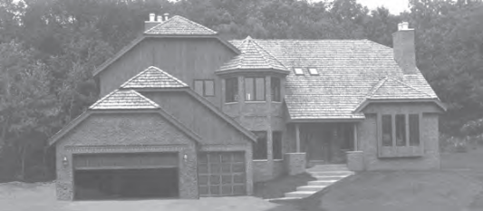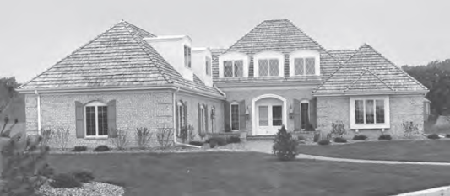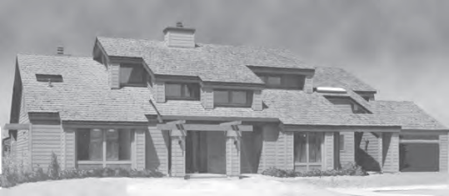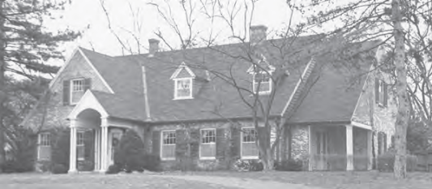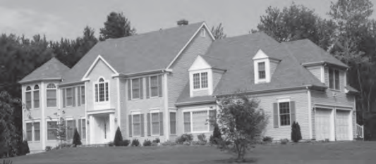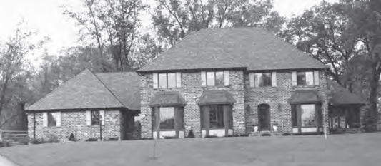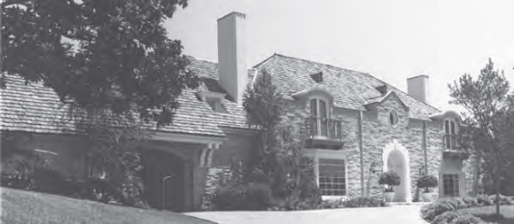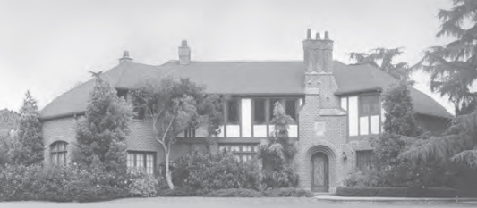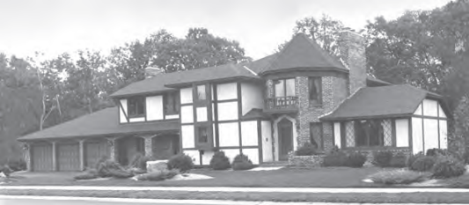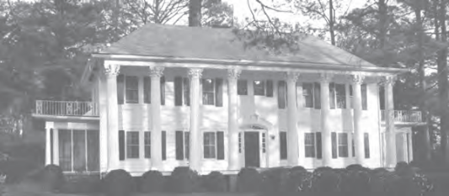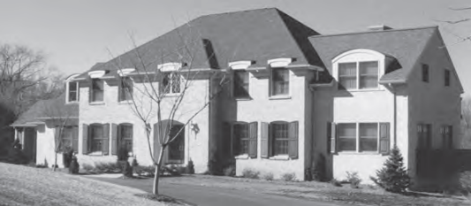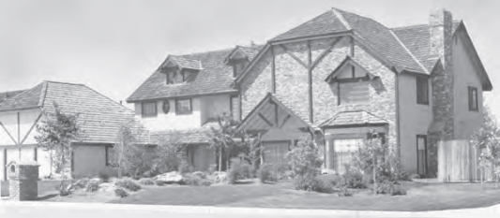

Fenestration is the arrangement, proportioning, and design of windows and doors in a building.
Core Logic. Marshall & Swift Residential Cost Handbook (RCH) 2018.

